**Дата**: 21.02.2025

**Клас**: 3-АБ

**Предмет**: англійська мова

**Тема:** Let`s play. Узагальнення з теми.

**Мета:** : формувати навички вживання лексичних одиниць по темі; удосконалювати навички читання, аудіювання й усного монологічного мовлення; розвивати пізнавальні інтереси учнів; виховувати інтерес до самостійного пошуку потрібної інформації, а також загальну культуру учнів.

**Вчитель**: Руда Д.В.

Хід уроку

1.Greeting

Good afternoon, guys! I’m glad to see you. Are you ready to start our lesson? All set?

2. Wаrm up / Listening

Уважно слухати аудіо трек і дати відповідь на питання вчителя <https://www.youtube.com/watch?v=5I0zggM8nZA> .

3. Speaking

Have you ever been bitten by a dog?

Have you ever been bitten by a snake?

Have you ever been to a farm?

Have you ever been to a zoo? What animals did you see there?

Have you ever eaten rabbit meat?

Have you ever gambled on a horse race?

Have you ever given your pet a bath?

Have you ever had a pet? / Have you ever had any pets?

Have you ever ridden a horse? How about a camel?

Have you ever seen a bullfight?

Have you ever seen a dog race?

Have you ever seen a dog that helps people, such as one to help a blind person?

If so, what did you notice about the dog?

How do you think that dog was trained?

Have you ever seen a "therapy dog?"

How long do you think a dog can live without food?

How many birds do you know that can't fly?

How many legs does a spider have? How about a squid?

How many national animal preserves do you have in your country?

Are there any animal preserves around here?

How many pets have you had?

How many pets have you raised and what are they?

How many zoos have you been to?

How much does it cost to keep your pet?

If you could be an animal, what would you (choose to) be? Why?

If you don't keep pets, please explain why?

Is is right to keep animals in a zoo?

Is it harmful for a dog to travel in cabin on a airline under the seat where your carry-on bags go?

Pets are considered to be a burden to most of the city dwellers. To what extent do you agree?

Some people think that people shouldn't wear animal furs. Do you agree? Why or why not?

Think of some people you know. Which animals do they resemble?

What animal do you think is the funniest?

What animal do you think is the strangest-looking?

What animal do you think makes the best pet? Why?

What animal would you like to be? (Which animal...?)

What animals are symbols of your country?

What animals are you afraid of? (...scared of?)

4. Повторення

*Словник:*

*Cloudy-хмарно (клауді)*

*Foggy-туманно (фогі)*

*Sunny-сонячно (сані)*

*Chilly-прохолодно (чілі)*

*Frosty-морозно (фрості)*

*Rainy-дощова погода (рейні)*

*Snowy-сніжна (сноуві)*

*It is raining dogs and cats- сильно дощити (ітс рейнін догс енд кетс)*

*In front of-попереду(ін франт аф)*

*Behind- ззаду(біхайнд))*

*Rainbow-веселка(рейнбоу)*

*Clouds-хмари(клаудс)*

*River-річка(ріва)*

5. Writing

Виконати письмово вправу подану нижче.

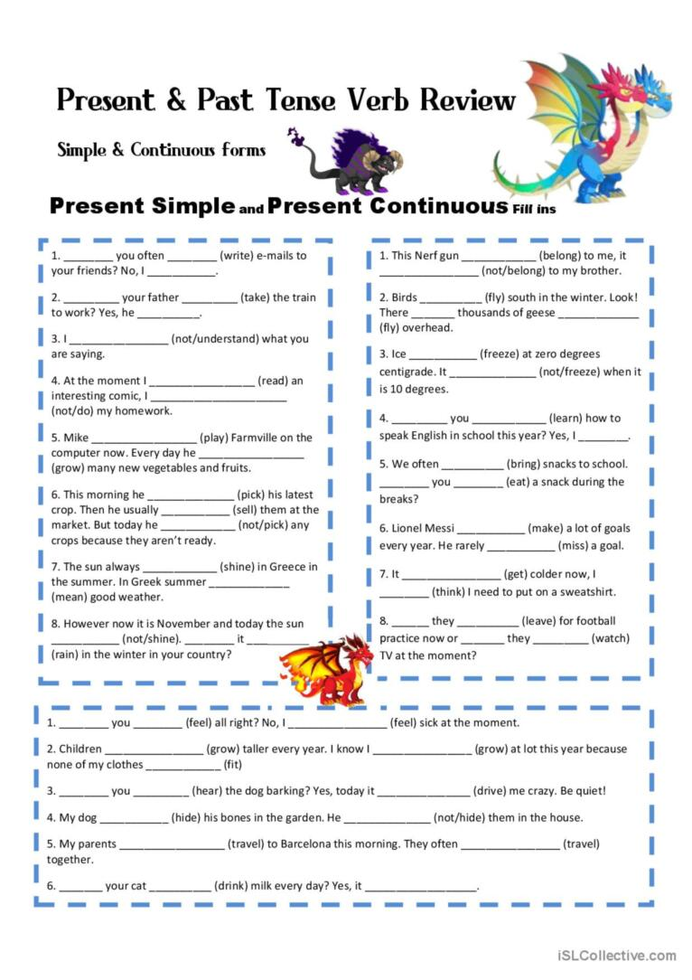

6. Homework

1. Виконати вправу подану нижче. (на повторення тварин)

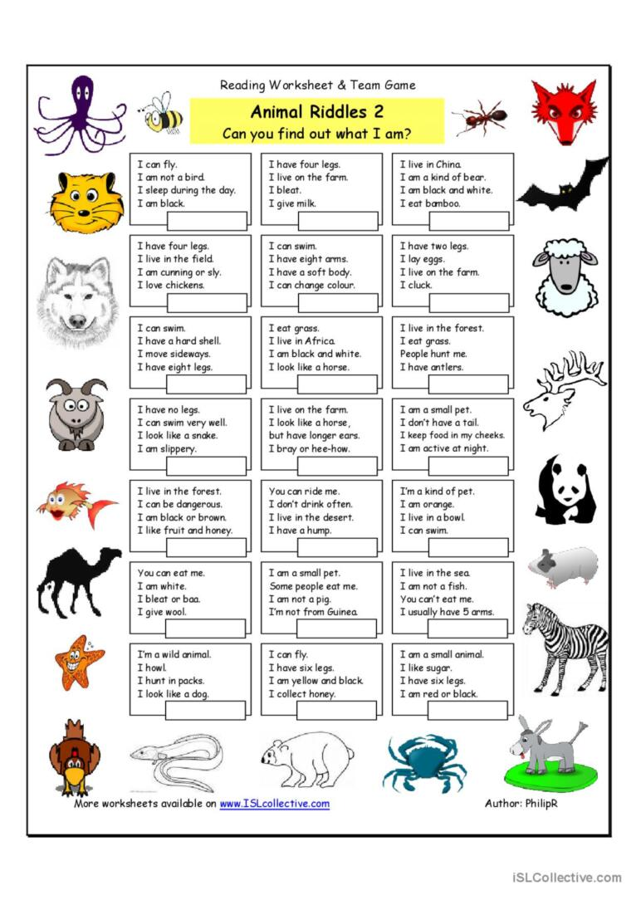

2. Повторити слова в конспекті, також вживання was/were.